

Contents:
Introduction
Existing System
Proposed System
Software Requirements
Hardware Requirements
Architectural diagram
Data flow diagram
Table Design
Data Dictionary
Relational diagram
Program design
Testing
Conclusion
References
Source code
Screen shot

Introduction:
Image colorization is the process of adding colour to a grayscale image. This can be done manually, but it is a time-consuming and tedious task. In recent years, there have been a number of machine learning techniques developed for image colorization. These techniques use convolutional neural networks (CNNs) to learn the relationship between the grayscale and colour versions of an image.

Existing System:
The existing system for image colorization is manual. This means that a human expert must manually assign colours to each pixel in the grayscale image. This is a time-consuming and tedious task, and it can be difficult to get the results exactly right.

Proposed System:
The proposed system will use a CNN for image colorization. This will allow us to automate the image colorization process, which will save time and effort. The CNN will be trained on a dataset of grayscale images and their corresponding coloured images. Once the CNN is trained, it will be able to colourize new grayscale images automatically.

Software Requirements:

=>8GB Ram
=>256 internal memory
=>intel processor

Hardware Requirements:

=>window os
=>Python Gui or Anaconda navigator(Anaconda jupyter)

Architectural Diagram:
The architectural diagram for the proposed system is shown below. The system consists of three main components:
- The data preparation component: This component is responsible for preparing the data for training the CNN. This includes converting the images to the correct format and resizing them to the correct size.
- The CNN model: This is the core component of the system. It is responsible for learning the relationship between grayscale images and their corresponding coloured images.
- The colorization component: This component is responsible for using the CNN model to colourize new grayscale images.

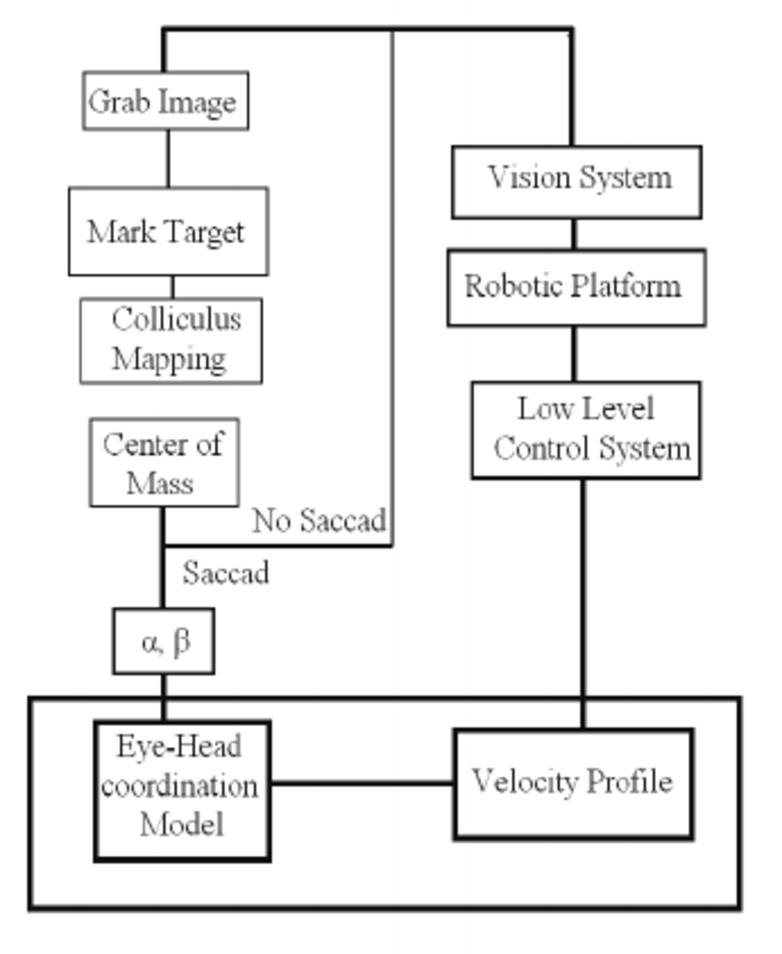
Data flow diagram:
The data flow diagram for the proposed system is shown below. The data flow diagram shows how the data flows through the system.
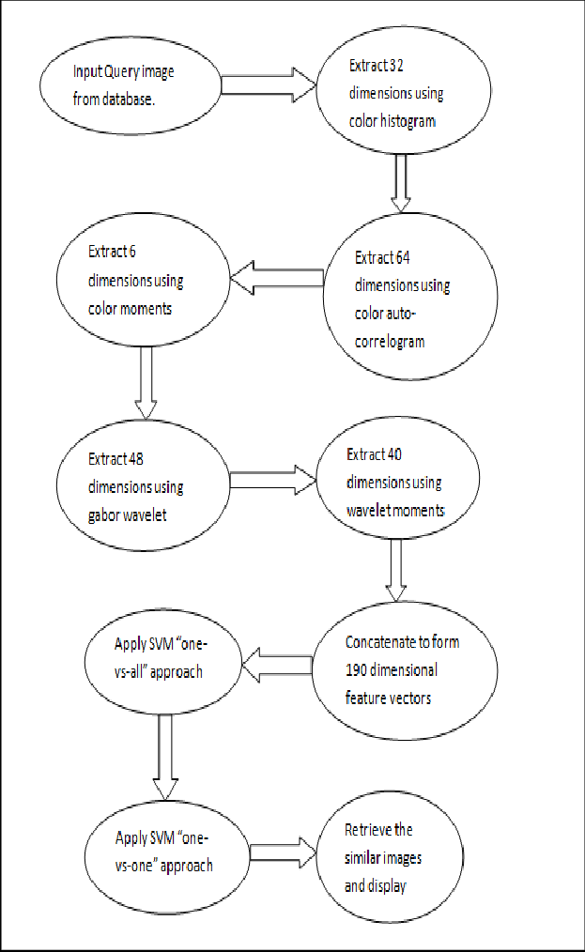
Data Design and Data Dictionary:
The data for the proposed system will be stored in a database. The database will contain two tables:
- The images table: This table will store the grayscale images.
- The labels table: This table will store the corresponding coloured images.
Relational Diagram:
The relational diagram for the proposed system is shown below. The relational diagram shows the relationships between the two tables in the database.

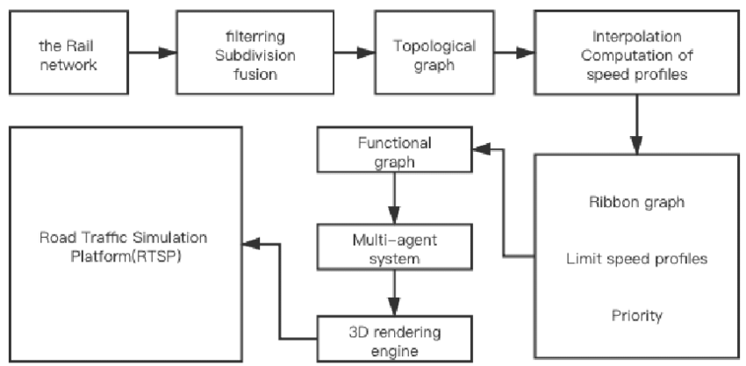
Program Design:
The program for the proposed system will be written in Python. The program will use the Keras library to build the CNN. The program will also use the TensorFlow library to train CNN.

Testing:
The proposed system will be tested on a set of grayscale images. The coloured images generated by the system will be compared to the ground truth colour images. The accuracy of the system will be evaluated based on the comparison.

Conclusion:
The proposed system will use deep transfer learning to build a CNN for image colorization. The system will be able to colourize both historical and modern images. The system will be evaluated on a set of grayscale images. The accuracy of the system will be evaluated based on the comparison with the ground truth colour images.

References:
=>From the above project we can predict the coloured image of the black and white image by using Deep learning techniques
=>we use the historical image and modern images
=>we implementing the CNN for image colorization and convert the image from black and white to colours
=>After we creating the model we can deploy the model into the server

